XBeam Rate Coordinate Systems

# Introduction

This document describes the various coordinate systems used by the XBeam Rate software.

# General Directions

Left and Right refer to the left and right hand side of the pier looking head on station.

# Pier Coordinates

Pier Coordinates are a planar coordinate system in the plane of the pier. The origin of the X axis is at the roadway alignment. The origin of the Y axis is at elevation of 0.

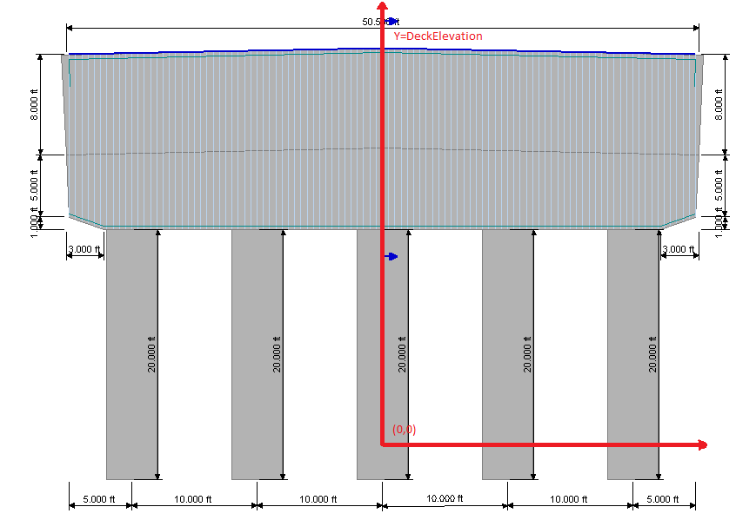

# Cross Beam Coordinates

Cross Beam Coordinates are a one-dimensional linear coordinate system measured along the cross beam. The origin of the coordinate system is at the left edge of the cross beam.

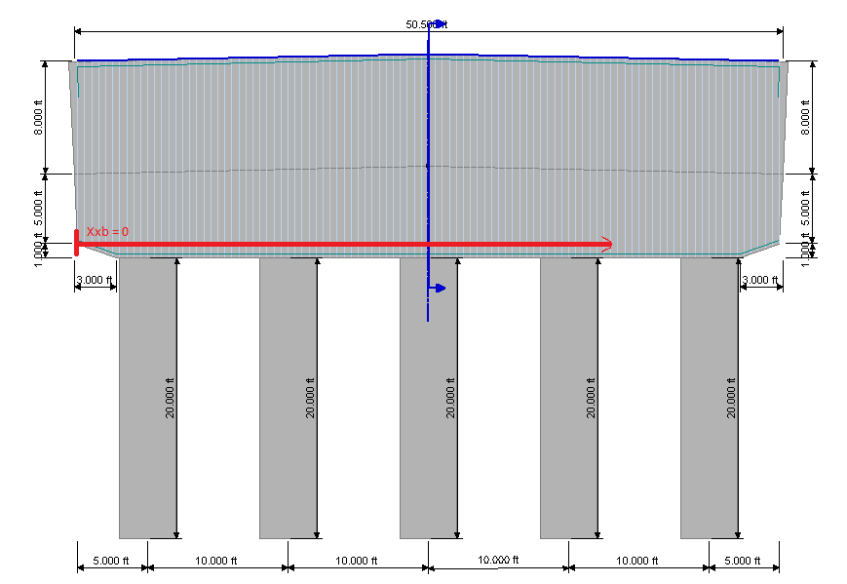

# Deck/Curb Line Coordinates

The Deck/Curb Line Coordinates are a one-dimensional linear coordinate system measured along the deck from the left curb line. The origin of the coordinate system is at the left curb line.

